My Job Selection Criteria

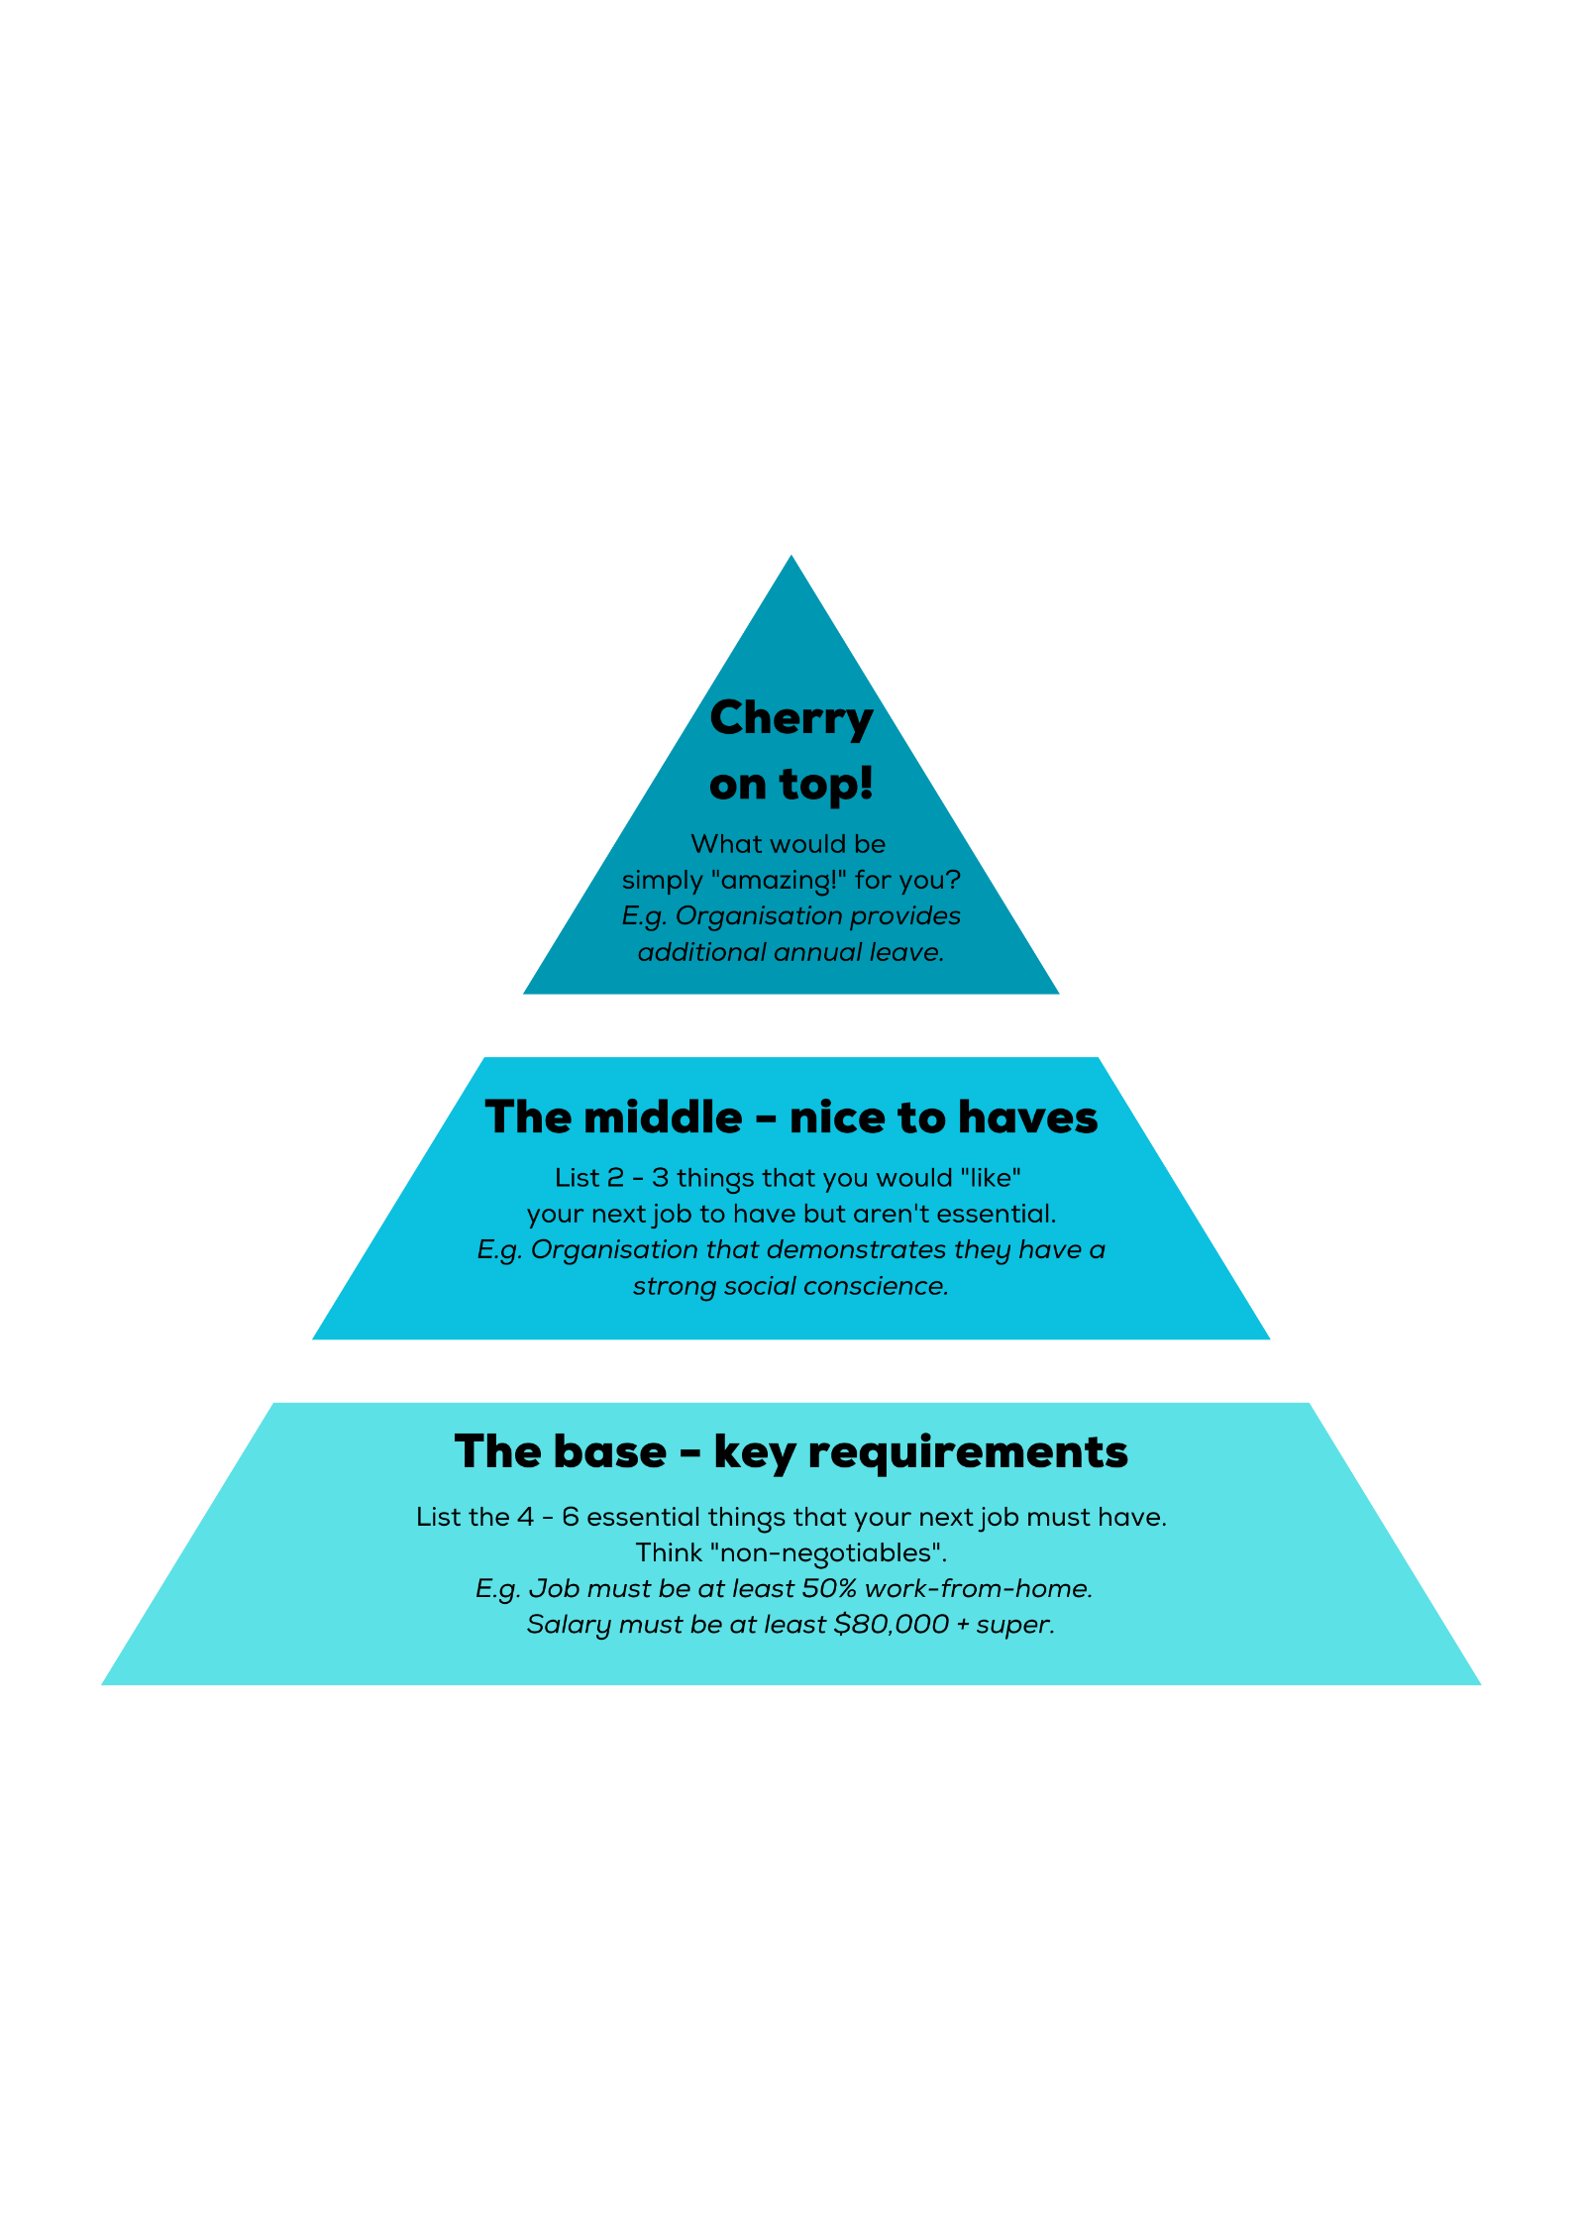

1.

2.



1.

2.

3.



1.

2.

3.

4.

5.

6.